The Lebanese Perception of the Endokarstic Patrimony

Prepared by: DOUMIT Laudy^{(1,2)}
laudy.doumit@usj.edu.lb

Under the supervision of: ADJIZIAN-GERARD Jocelyne^{(1,2)}, GAUCHON Christophe⁽²⁾.

- Department of Geography, Saint-Joseph University, Beirut, Lebanon.
P.O. Box: Département de Géographie - Campus des Sciences Humaines, rue de Damas
B.P. 17-5208 Mar Mikhael, Beyrouth 1104 2020 - Liban
- EDYTEM (Environment, Dynamics and Mountain Territories), UMR 5204 CNRS - University of Savoy, France.

Abstract:

The endokarstic patrimony is strongly threatened by degradation in Lebanon. Fault of being unaware of its value, the authorities appear indifferent regarding to this situation. The population aim for short-term profitability, often cause, by ignorance, irreversible damage in this field.

However, in other countries like France or Slovenia, the endokarstic patrimony represents, through tourist valorization, a socio-economic development factor. Why isn't it the case in Lebanon?

A survey that was conducted on 600 individuals has enabled us to apprehend on the one hand, the given meaning of the inheritance term by the Lebanese people and in the other hand, their perception of the karstic inheritance.
This communication discloses the first results of this investigation.

Keywords: Lebanon, karst, grottos, patrimony.
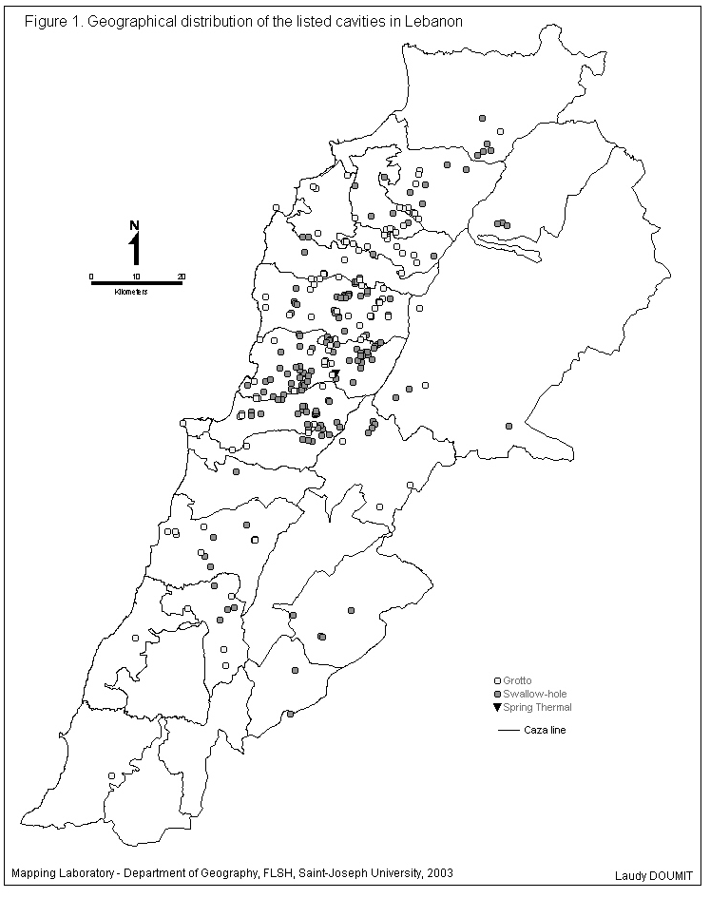
65% of the surface of Mount Lebanon is formed with karst and accordingly constitutes a considerable natural patrimony. It is undoubtedly the most important in the country. The first speleological club in Lebanon was founded back in 1951 and, ever since, over 500 underground cavities have been discovered and listed across the whole territory.
Amongst these cavities, 283 were found to reach above 20 meters of development. Whilst all the caves are relatively ignored by public institutions and by the public, certainly due to some unconsciousness towards their patrimonial aspect and value, only one cave is well-known to Lebanese tourism and considered as famous: the Jeita Grotto.

Moreover, this patrimony is highly threatened by degradation. Furthermore, authorities and officials seem indifferent to this situation. The population seeks short-term profits, thus causing irreversible damage to this site by unawareness or through the non-authorized exploitation of quarries.

However, in other countries like France or Slovenia, the endokarstic patrimony is viewed as a factor of socio-economic development, through the development of tourism. Why is that not the case in Lebanon? Is this due to the apparent indifference of the Lebanese people for the patrimonial aspect? Or is it caused by ignorance of the karst as a natural engine of national socio-economic development?

We wished to investigate further so as to better understand such a particular behavior vis-à-vis this inheritance.

A survey conducted on 600 individuals has enabled us to apprehend on the one hand, the meaning conveyed by the Lebanese people to the term "patrimony" and on the other hand, their perception of the karstic inheritance. This speech discloses the primary results of the investigation.

- The Notion of Patrimony Amongst the Lebanese

In a country emerging from a Civil War, where officials seem totally indifferent regarding patrimony and make no effort whatsoever for its development, we have questioned the population about the meaning it conveys to this term.

It has turned out that first and foremost, patrimony is of historical nature. Out of 600 people enquired, 372 have mentioned the aspect. Other criteria follow: Patriotic (220), cultural (209) and hereditary (111).

As a statement of fact, the notion of patrimony amidst the Lebanese rarely or never includes the natural aspect; it has only been mentioned by 34 people, in other words 5.6% of the sample.
Only one person considers patrimony as an economic resource!

What is more, when asked about patrimonial elements in their region of origin or residence, 38% of the interrogated Lebanese answered that none existed! When they were capable to name any, they mostly mentioned either historical or archeological sites or regions and streets and houses of traditional nature or religious sites.

Nevertheless, having classified patrimonial elements in order of importance on the national scale in Lebanon, grottos come in third position (125 people) after archeological and historical sites, as well as after traditions and customs.

Be that as it may, this does not mean that the Lebanese acknowledge the real value of the grottos, for the most frequently mentioned element, the famous Jeita Grotto is a developed and promoted karstic site.

In fact, it is one of the most impressive natural sites in the Middle East, exploited by the State and a private company. It contains 2 galleries: in the upper gallery, 2200m have been explored, out of which 800 are fitted out. As for the lower gallery, 6200m have been explored, out of which 600 are open to the public.

- The Lebanese and Grottos

Does the fact that the Lebanese people do not primarily think about grottos mean that they have no interest whatsoever for this kind of site?

  - Sites visited by the Lebanese

In our survey, we have asked people to name the activities and kinds of visits they undertake while receiving foreigners. Amongst the activities mentioned, visiting grottos came in third position (228 people), following visits to historical and archeological sites (460 people), and lunch invitations (429 people).
Once more, the Jeita Grotto prevails on other grottos. Indeed, 87% of the mentioned grottos belong to this one and same cavity. Only 9% include two other developed and promoted cavities in Qadisha and Kfarhim, but represent no competition for Jeita.
To what extent do these answers translate the real attendance to tourist grottos?

  - Underground Tourism in Lebanon

Out of 600 interrogated individuals, 436 (73% of the sample) have visited at least one grotto through their life. In order to complete this first information, we have also asked people who have visited at least one grotto whether they knew of other grottos then asked those who have never visited any grotto if they knew of one at the least.

- People having already visited grottos

Out of 436 people who have already visited grottos, 209 know of other grottos, thus 48% (Figure 2).

Generally, the cavities they have mentioned are those developed and promoted. The same names turn out: Jeita (21%), Qadisha (19%) and Kfarhim (9%). Hence, the Lebanese seem to respond to promotions they are subject to.

Figure 2 – Knowledge of the Lebanese about grottos.

Nevertheless, other grottos have been referred to (39%). In most cases, they are not well-known; they are scattered in various areas of the country, often close to the region of residence or of origin. For the most part, people are incapable of naming these cavities. They simply state the name of the region of location.

Only 1% of the Lebanese have visited grottos with social clubs and sports clubs or various associations. Predominantly, they organize these types of visits in groups of friends (39%) or as family (28%). In some cases, visiting grottos takes place in the frame of outings organized by schools for their students (12%). In other cases, Lebanese people accompany tourists throughout well-known tourist sites in Lebanon (7%).

The principal reason for visiting is curiosity (27%). It is followed by the reputation of the site (20%) and the wish to introduce it to other tourists (16%). Only 3% do it for the pleasure of sports activities.

Many reason leads them back to a grotto they have previously visited. In point of fact, out of 436 individuals who have already visited grottos, 293 have returned to the cavities many time. 25% explain their return through the aesthetic ascpect of the grotto. 18% come back to accompany other people. These reasons are succeeded by curiosity (12%), natural causes (11%), and feeling like participating in organized outings (7%). 27% refer to other reasons: 17% of them explain that through the geographical location of the grotto and its closeness to their area of residence and 14% of them mention religious causes.

- People who have never visited grottos

We have asked people who have never visited grottos to name the cavities they know. Indeed, 92% of them have named the most famous ones: Jeita 57%, Qadisha 10%, and Kfarhim 7%.

Eventually, out 164 individuals who have never visited cavities, 85% are interested by this sort of outing. However, various reasons have hindered them from doing so up until now: high visiting fees, lack of motivation…

  - Visiting non-developed grottos in Lebanon

Out of 436 people who have previously visited one grotto to the least, 145, thus almost one third of them admit having visited one or many non-developed grottos in Lebanon. Anyhow, only 6 of them have practiced actual caving. The rest were content with simply visiting the entrance of grottos (97 people) or with small non-technical visits (42 people). Still, all consider themselves as having visited non-developed grottos. In order to verify the accuracy of these results, we have asked the enquired individuals to list the necessary equipment for grotto visits.

In order to verify the accuracy of these results, we have asked the enquired individuals to list the necessary equipment for grotto visits. It seems that 108 have used no equipment whatsoever. 30 people had but a torch and only 7 people were fully equipped (helmet, torch, harness, ropes…)
Consequently, these results verify that the Lebanese do not practice professional caving. Those who venture in the underground do so with no technique. As for the satisfaction they get from the visits, out of 145 people, 129 have appreciated the visit and 104 are ready to start it over.

- How the Lebanese describe Grottos

In order to better grasp the practice of underground tourism in Lebanon, and consequently understand the interest Lebanese people have in protecting and developing this milieu, we had to find out how they perceive these cavities.

- The Grotto: a Tourist Site

98% of the Lebanese believe that a grotto can be a tourist site based on various criteria which attract tourists.

Out of 600 individuals interrogated about the criteria that allow a grotto to become a tourist site, 39.8% refer to its natural aspect. We have noted that just a small minority (5.6%) of the sample considered the natural aspect to be part of the patrimonial characteristic of a good: this discrepancy confirms the difficulty Lebanese people have to perceive grottos and karst as an inheritance.
Following this criterion come the artistic characteristic – notably aesthetic – (35.5%) and its historical characteristic (25.8%). 22% refer to the rare and unique aspect of a grotto and 15% refer to its picturesque aspect. 7% think that it is the development of a grotto which turns it into a tourist site. 6% believe that it is due to its relation to the country: it was formed within the territory and thus became a national symbol.

4 of the characteristics mainly cited by the Lebanese (artistic, picturesque, historic and natural) are present in the texts of the UNESCO, which set 6 criteria to apply patrimonial protection. The missing criteria in Lebanon are: legendary, named by only 2 people, and architectural, named by only 9 people.

Nevertheless, only 29 individuals spontaneously think of it as an inheritance, thus 4.8% of interrogated people. Also, only 11 consider the grotto as an economic resource, thus 1.8% of the sample. Accordingly with these astonishing results, we have sought to study the profile of the latter (Table 1).

Table 1: Profile of individuals who believe grottos are touristic sites because they are an economic resource.
Number of individuals | Sex | Age | Mohafazat of Residence | Profession
1 | F | 15-19 | Beqaa (except for Zahle) | Student
1 | F | 15-19 | Saida | Student
1 | F | 20-29 | Beirut | Tradesman
1 | F | 30-39 | North Lebanon  (Except for Tripoli) | Liberal Profession
1 | M | 20-29 | Beirut | Liberal Profession
1 | M | 20-29 | South Lebanon  (Except for Saida) | Student
1 | M | 20-29 | Tripoli | Student
1 | M | 30-39 | Beirut | Craftsman
1 | M | 30-39 | Nabatiyeh | Employee
1 | M | 40-49 | Beirut | Tradesman
1 | M | 40-49 | Nabatiyeh | Liberal Profession

Apparently, the majority are male. Despite the small size of the sample, we have come up with the following hypothesis: men are more sensitive to the economic aspect than women.

9 persons are between 20 and 49 years of age: they essentially belong to the working population.

We took notice of the fact that these people live in different regions of Lebanon. As for their professions, 4 are students, 3 have a liberal profession and 2 are tradesmen. They all belong to the intellectual class.

- The Grotto: Country's Patrimony

We have asked people if in their point of view, a grotto could belong to a country's patrimony. 79% have answered "yes". As a matter of fact, it seemed as though the question dictated the answer.

These people consider the grotto as a patrimony due to its historical aspect (223), its patriotic (128), natural (123), artistic (65) and rare and unique (58) aspects.

One can see that the characteristics mentioned to show the patrimonial aspect of a grotto are quite the same as the ones listed to explain its tourist aspect (cf. § 3 a). However, the priority is not the same. A grotto is tourist first and foremost because it is natural and artistic and it is patrimonial due to its historical character. The Lebanese associate patrimony to everything historical, ancient and archeological. The legendary, architectural and picturesque criteria mentioned by the UNESCO are rarely or never cited. Moreover, Lebanese people are unable to see patrimony as an economic resource, since only 9 people mention this criterion, thus 1.5% of the population.

These people who insist on the economic role of patrimony are all males (Table 2). They also have a high social standing.

Table 2: Profile of individuals who believe grottos belong to the patrimony because they are an economic resource.
Number of individuals | Sex | Age | Mohafazat of Residence | Profession
1 | M | < 15 | Beqaa (Except for Zahle) | Student
1 | M | 15-19 | South Lebanon (Except for Saida) | Student
1 | M | 20-29 | Outskirts of Beirut | Civil Servant
1 | M | 20-29 | Outskirts of Beirut | Employee
1 | M | 20-29 | Tripoli | Employee
1 | M | 40-49 | Outskirts of Beirut | Liberal Profession
1 | M | 50-59 | South Lebanon (Except for Saida) | Teacher
1 | M | >= 60 | South Lebanon (Except for Saida) | Retirement
1 | M | >= 60 | Rest of Mount Lebanon | Liberal Profession

In conclusion, the awareness of the Lebanese can easily be sought for the protection and development of endokarstic patrimony. They admit that a grotto is altogether natural, historical, artistic and unique… It has all the assets to be considered as tourist and patrimonial. The Jeita Grotto which attracts so many people is the ideal proof of the interest that Lebanese could have for this patrimony.

However, they are not aware that it represents an opportunity for economic activity and benefits. Consequently, they are unable to see the financial and environmental importance to protect this natural milieu.

At this point, one question should be asked: if the Lebanese are unaware of the importance of patrimony preservation, is that a direct consequence of their education? Would awareness to the importance of this phenomenon not be a sine qua non condition to ensure the success of any program of patrimonial development, especially when, in the words Georges S. ZOUAIN (1999), this failure in the vision leads to an artificial dangerous and negative antinomy between patrimony and economic development?

Setting forth the potential of a lasting and realistic economic development of these sites, the locals could more concerned with preserving this environment and would take knowledge of the socio-economic risks linked to the disappearance of this patrimony.

Bibliographic references:

- ABDUL-NOUR Hani (2004): Les cavités de l’endokarst au Liban, Spéléorient, numéro 4 , pages 116 – 128.

- ZOUAIN S. Georges (1999): Du patrimoine dans l’état moderne, Réflexions et éléments d’une politique, 16p.

